Mixed Reception Class Assignment

While you watch the introduction video, note below your preliminary thoughts about which person/people you personally suspect, and why & how they might have done it.

The principal suspects according to my observation are Sam, Joanna, Vince, Nelson and Dr. Yevin, in that order. Sam was jealous and bitter; jealous because Nelson gained recognition for his work more than him and bitter because no one, especially Nelson, valued his computer modelling. He could have killed Nelson to prove a point and possibly teach him a lesson.
Joanna is a jealous girlfriend. She is convinced that Nelson is cheating on him. Nelson’s pills were also found in her house. She might have switched them to get back at Nelson. When Joanna arrived at the scene, Vince changed the story. It could have been she did not want Vince to tell Nelson what was going on or he did not want her to find out about the research. This could make Vince part of a larger scheme.
Dr. Yevin might have subjected Nelson to get results faster, possibly asking him to try the new drug without caring how it would have affected Nelson. His main agenda was to get results, and to get them fast.
Nelson, the victim is also a suspect. He is overly ambitious and might have gone ahead to try the novel drug on himself.

While you interview suspects and gather evidence, make notes below about each suspect – do you personally suspect them? What reasons might they have had to commit the crime, and most importantly, how might they have done it? What were their means?

  Dr Yervin | Do you suspect this person? Yes  What is their motive? He might have pressured Nelson too much to get results. This might have led to him taking the new drug. He was also jealous that Nelson might get the recognition more than him and he was the pioneer of the project. He did not like Nelson’s ambition.  How might they have done it?  He pioneered the creation of the Compound C, a substance incriminated in Nelson’s death.
  Sam | Do you suspect this person? Yes  What is their motive? He was offended by Nelson’s flippancy and was jealous of Nelson. Jealous that people were not paying attention to his computer modelling work.  How might they have done it?  The punch that he offered to Nelson might have caused Nelson’s death. He might have laced the food he offered Nelson with a poisonous drug; The unidentified substance.
  Joanna | Do you suspect this person? Yes  What is their motive? Jealousy. She was insecure that Nelson was cheating on him.  How might they have done it?  She might have switched the allergy medication with different drugs, hoping to teach Nelson a lesson.
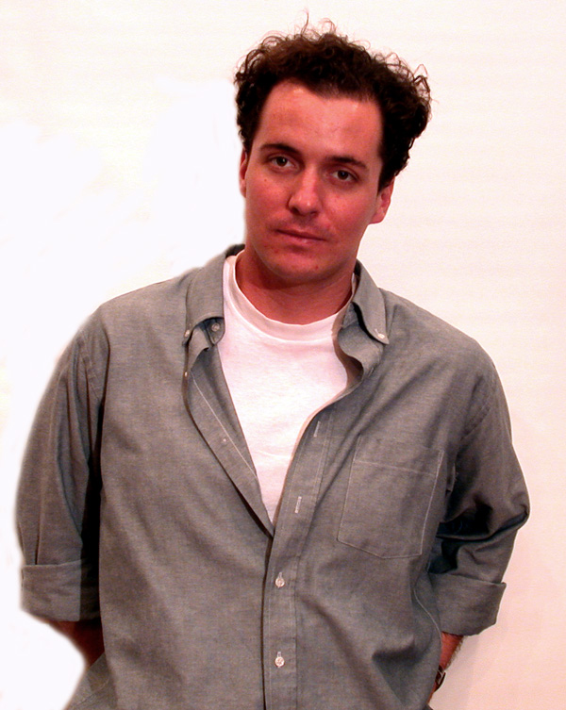  Vince | Do you suspect this person? Yes  What is their motive? He is very close to Nelson, no one would suspect him. He might not have had a personal motive but people might have used him.  How might they have done it?  He knew that Nelson was trying the novel drug on himself and he did not stop him.
  Nelson | Do you suspect this person? Yes  What is their motive? He wanted to gain recognition for his work. This might have pushed him to try the new drug on himself  How might they have done it?  Through taking the trial drug by himself.

While you gather evidence, make notes below about how each piece of evidence might relate to a suspect, how it might have been used in the crime, etc.

  Drug Info Sheet | The info sheet relates Joanna to the crime. It bears information of the same drugs that were found in Joanna’s office. Thus it can be used to corroborate Joanna’s involvement.
  Joanna’s Emails | These relate Joanna to the crime. Its possible use in the actual crime is not clear. However it emphasizes on Joanna’s motive of jealousy.
  Anti-Toxin Report | This links Sam to the crime. It will show if there was any modification on the original compound or if it could possibly cause anaphylaxis in humans the same way peanut butter does. It could also show any drug interactions available.
  Punch | This relates Sam to the crime. It could have contained the unidentified substance in Nelson’s blood.
  Coroner’s Report | The report incriminates Sam. The unidentified compound might have been his creation. It could be a drug that attenuates the protective medication of the anti-allergy medication. The report is useful in the investigation as it reinforces Sam’s involvement.
  Nelson’s Journal | The information in the journal will shed some light on what Nelson experimented on and his possible involvement in his own demise.
  Peanuts | These incriminate Dr. Yevin. He possibly knew of Nelson’s allergy to peanuts that is why he might have included them in the party.
  Peanut Pie | This relates Sam to the crime. He offered it to Nelson. It had peanut, the cause of the allergy that killed Nelson and possibly the unknown substance.
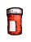  Nelson’s Pills | These relate Joanna to the crime. They might have been switched by Joanna. Nelson consumed them thinking that he was taking allergy medication.
  Pills from Joanna’s Office | These confirm that Joanna knew about Nelson’s allergy medication. She had earlier denied knowing about the drugs Nelson was taking. This evidence incriminates Joanna. Joanna’s fingerprints on the vial would further incriminate her.

Use this page for additional notes, calculations, and conclusions you make as you analyze the evidence and form your conclusion.

When you’re ready to report your findings, call a teacher over. They’ll interview you as you report the cause of death, the guilty party, and the evidence that lead you to your findings.

Case Report Form

Student’s name:

- List all evidence collected at the scene. Should something else had been collected?
Punch, peanuts, punch finger prints and peanut pie, were collected at the crime scene.
The source of the punch and the peanut pie should have been investigated.

- An unknown substance was present in Nelson’s blood. What was this substance and how did it get into his blood? What evidence do you have to support this?
The substance is a combination of two drugs. The first drug is the anti-allergy medication which had a molecular weight of 167.16 (formic acid 5-amino-2-hydroxy-benzyl ester), and the second one is the protein c compound of molecular weight 598.66. Addition of these two molecular weights results in a MW of 765.82, the unidentified substance. The compound c could have been ingested willingly by the victim such. As such it could have bonded with the formic acid 5-amino-2-hydroxy-benzyl ester in vivo. Or it could have been engineered by Sam and put in the punch.
- The molecular weight of the unknown substance in Nelson’s blood is 765.82? Why?
It is a combination of formic acid 5-amino-2-hydroxy-benzyl ester and compound C (167.16+598.66=765.82)

- What is the MW of the allergy drug?
167.16

- What is the MW of the anti-venom?
598.66

- The coroner says that Nelson died from peanut allergy, yet he was taking a drug for this. Can you explain why he would still die from peanuts?
Since the Compound C tightly binds to compounds with the same conformation as the spider venom, it bonded to the formic acid 5-amino-2-hydroxy-benzyl ester thus reducing its potency. Therefore, Nelson was vulnerable to peanuts allergy.

- Did Nelson take his medication that day? Was the correct concentration of medication present in his blood? He took his medication that day. No, the concentration was reduced.

- Using your analysis of the evidence, would you say the victim died from an accident or a murder? Explain how you came to that conclusion. What evidence was relevant to your conclusion and why?

Even though Nelson’s death seems to be pointing towards Sam as the perpetrator, evidence shows that it was an accident. The novel compound in Nelson’s blood is a combination of formic acid 5-amino-2-hydroxy-benzyl ester, an active ingredient in the allergy medication and Compound C, after calculation of the molecular weight. It is highly likely that Nelson’s ambition and enthusiasm led to him to try the Compound C on himself. A spider was noted in his apartment. He possible tried to inject himself the spider venom and see if the anti-venom worked. However, he did not know that this compound would interact with his allergy medication as it binds tightly to compounds similar to the venom. This reduces the bioavailability of the anti-venom medication and thus its efficacy drastically reduces leaving the person vulnerable to peanut allergy. Therefore anaphylaxis would occur if Nelson consumed peanuts or food made from the same.

